**Quiz**

1. **What genre of game are we building in this section?**
   1. Shoot’em’up
   2. First person shooter
   3. Flight Simulator
   4. Rails Shooter
2. **Which of the following is true regarding Rail Shooters?**
   1. They allow you to reuse your environment by flying your player through the same location but in different ways.
   2. They give the player full control over where they want to go in the world.
   3. There are way too many Rail Shooter games on the market nowadays, there is not possibly any room for another one.
   4. They absolutely have to be created with some kind of flying ship or else they are no fun.
3. **Where do you find the setting that defaults new scenes to 2D or 3D?**
   1. You cant once you’ve setup a project
   2. Just toggle in Scene tab
   3. Edit > Project Settings >Editor
   4. From the Preferences menu
4. **Where would you find the Terrain Height setting, which controls the total vertical extent of the terrain from lowest to highest?**
   1. Click Terrain > Inspector > Set Terrain Height (2nd button)
   2. Window > Terrain > Settings
   3. Click Terrain > Inspector > Brush
   4. Click Terrain > Inspector > Settings (Cog) > Resolution Section
   5. You cant change this.
5. **Where would you click to add a new texture to use on your terrain?**

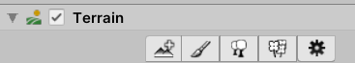

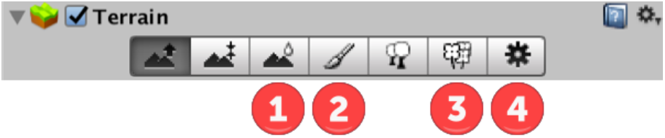

* 1. 1
  2. 2
  3. 3
  4. 4

1. **What is the easiest way to assign a skybox material to your scene?**
   1. Drag the material to the sky
   2. Go to Window > Lighting > Scene Tab> Environment > Skybox Material
   3. Write some C# code to find the scene by string, and assign the material.
   4. You can only assign to a scene from the material its self.
2. **How many ships can you build using the supplied assets?**
   1. 1
   2. 3
   3. 5
   4. Unlimited
3. **What is the minimum number of scenes in the build order to implement an auto-loading splash screen?**
   1. 0
   2. 1
   3. 2
   4. 3
4. **Which statement is most true of what DontDestroyOnLoad(gameObject) does?**
   1. Prevents the component from being destroyed on load, but allows the game object to be destroyed.
   2. Prevents all game objects with the same name as the one the script is attached to from being destroyed when the scene loads.
   3. Prevents all game objects from being destroyed when you load the next scene.
   4. Prevents the game object that this script is attached to from being destroyed when a new scene is loaded.
5. **How do you specify waypoints to the waypoint circuit script in Unity's standard assets?**
   1. Attach empty transforms as child objects
   2. You list their coordinates in the inspector
   3. You write them into code
   4. You drag each waypoint into an array in the inspector.